 |  |  | SIZE CHART
SIZE | XS | S | M | L | XL | XXL | XXL
BUST (BODY) | 32”-33” | 34”-35” | 36”-37” | 38”-39” | 40”-41” | 42”-43” | 44”-45”
WAIST (BODY) | 28”-29” | 30”-31” | 32”-33” | 34”-35” | 36”-37” | 38”-39” | 40”-41”
HIPS (BODY) | 35”-36” | 37”-38” | 39”-40” | 41”-42” | 43”-44” | 45”-46” | 47”-48”
GARMENT SHOULDER | 14” | 15” | 15.5” | 16” | 16.5” | 17” | 17.5”
GARMENT BUST | 36” | 38” | 40” | 42” | 44” | 46” | 48”
WOMEN (CHIKANKARI)

Please Note : This guide provides general sizing information only, and fit can vary depending on style and brand. For more specific sizing information on the product, please refer to product description.

Sizing & Fit Guide
Please be aware that all of our products are hand-made and hand stitched, hence there can be some minor adjustments issues to some of them. However, our team does its best to make sure that correct size is delivered to you.
If you’re on the borderline between two sizes, order the smaller size for a tighter fit or a larger size for a relaxed fit. However, please remember the larger size can always be altered if need be.
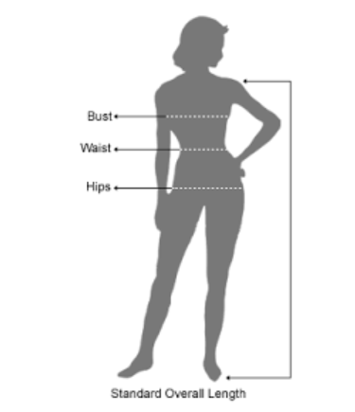
To choose the correct size for you, measure your body as follows:
- BUST – Measure around the fullest part.
- WAIST – Measure around natural waistline.
- HIP – Measure 20cm down from the natural waistline.

